Feral Cat Coalition Volunteer Questionnaire 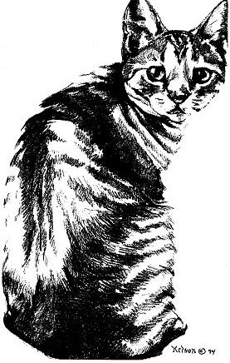
Thank you for your interest in becoming a Feral Cat Coalition volunteer! Please fill out this questionnaire to help us get to know you better. You may type your answers directly into this form, save, and email it to feralcats@cox.net. You may also print it, fill it out, and either scan and email, or mail it to 9528 Miramar Rd., PMB 160, San Diego, CA 92126

First Name:
Last Name:
Address:
City/State/Zip Code:
Home Phone:
Cell Phone:
Email:

 | Criteria | Yes/No | Comments
1 | Are you over the age of 18? | Yes  No
2 | Are you a Doctor of Veterinary Medicine (DVM) or Registered Veterinary Technician (RVT), Licensed Veterinary Technician (LVT) or Certified Veterinary Technician (CVT)? Please specify: | Yes  No
3 | Please select the areas in which you feel you have moderate to excellent skill: | Animal Care  Graphic Design  Event Planning  Fundraising  Public Speaking  Trap-Neuter-Return  Administrative Support  Writing/Editing
4 | Please select any language you can read, write, and speak fluently: | English  Spanish
5 | Please select the times that are most convenient to you: | Days  Evenings  Both
6 | Please select any days that are convenient for you: | Monday  Tuesday  Wednesday  Thursday  Friday  Saturday  Sunday
7 | Please let us know how frequently you’d like to volunteer. Selecting a frequency here does not commit you to any set time to volunteer: | Weekly  Bi-Weekly  Monthly  Project Volunteer
8 | If interested in trapping and/or transporting feral cats for spay/neuter, do you have a driver’s license, and a registered, insured vehicle in running condition? | Yes  No
9 | If interested in trapping and/or transporting feral cats for spay/neuter, how many cats can your vehicle accommodate? | 1-5  6 or more
10 | Please select any of the specific volunteer positions you are interested in: | Newsletter Editor  Spay/Neuter Counselor  Statistics Coordinator  Trap Depot  Trapper/Transporter  Veterinary Partner Contact  Volunteer Coordinator  Website Copy Editor

Please tell us more about the skills and experience you’d like to contribute to the Feral Cat Coalition, as well as any past volunteer experience you may have:

Agreement:
I understand and agree that submitting this application form does not automatically register me as a Feral Cat Coalition volunteer, and that there may be certain qualifications I must meet, including the acceptance of established volunteer policies and procedures, before I may begin volunteering. By submitting this form, I attest that the information I have provided is true and accurate.

I agree.

